Dual-homed AS

🌐 What Is Dual-homed AS?
# Source: AI Source: Provided by: [Data Path: Persons Table -> ID Column: 1, Name_En Column: Motasem Essam] -> From: [ChatGPT] on [1/16/2026]
A Dual-Homed AS (Autonomous System) is a network that connects to the same ISP via two separate links — providing redundancy and failover, but not provider diversity.
It’s a form of single-provider multi-connection, commonly used to improve availability without the complexity of multiple ISPs.

🧠 Simple Definition:
# Source: AI Source: Provided by: [Data Path: Persons Table -> ID Column: 1, Name_En Column: Motasem Essam] -> From: [ChatGPT] on [1/16/2026]
A Dual-Homed AS connects to the same ISP with two separate connections, ensuring internet access continues if one link fails.

🖼️ Visual Example
# Source: AI Source: Provided by: [Data Path: Persons Table -> ID Column: 1, Name_En Column: Motasem Essam] -> From: [ChatGPT] on [1/16/2026]
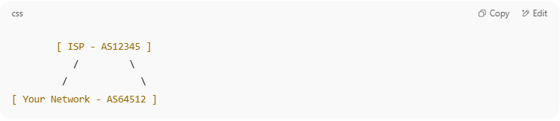
[ ISP - AS12345 ]
/ \
/ \
[ Your Network - AS64512 ]

- Your network has two BGP sessions with the same ISP.

🔧 Key Characteristics
# Source: AI Source: Provided by: [Data Path: Persons Table -> ID Column: 1, Name_En Column: Motasem Essam] -> From: [ChatGPT] on [1/16/2026]
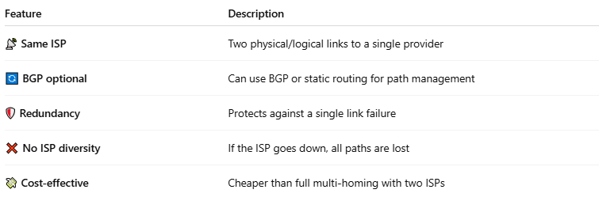
Feature | Description
📡 Same ISP | Two physical/logical links to a single provider
🔄 BGP optional | Can use BGP or static routing for path management
🛡️ Redundancy | Protects against a single link failure
❌ No ISP diversity | If the ISP goes down, all paths are lost
💸 Cost-effective | Cheaper than full multi-homing with two ISPs

✅ Pros and ❌ Cons
# Source: AI Source: Provided by: [Data Path: Persons Table -> ID Column: 1, Name_En Column: Motasem Essam] -> From: [ChatGPT] on [1/16/2026]
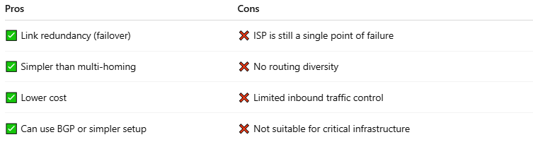
Pros | Cons
✅ Link redundancy (failover) | ❌ ISP is still a single point of failure
✅ Simpler than multi-homing | ❌ No routing diversity
✅ Lower cost | ❌ Limited inbound traffic control
✅ Can use BGP or simpler setup | ❌ Not suitable for critical infrastructure

🔁 Comparison with Other Setups
# Source: AI Source: Provided by: [Data Path: Persons Table -> ID Column: 1, Name_En Column: Motasem Essam] -> From: [ChatGPT] on [1/16/2026]
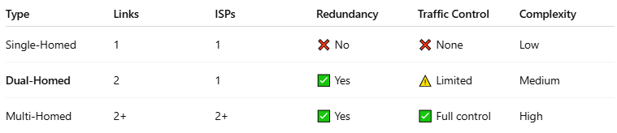
Type | Links | ISPs | Redundancy | Traffic Control | Complexity
Single-Homed | 1 | 1 | ❌ No | ❌ None | Low
Dual-Homed | 2 | 1 | ✅ Yes | ⚠️ Limited | Medium
Multi-Homed | 2+ | 2+ | ✅ Yes | ✅ Full control | High

✅ Summary
# Source: AI Source: Provided by: [Data Path: Persons Table -> ID Column: 1, Name_En Column: Motasem Essam] -> From: [ChatGPT] on [1/16/2026]
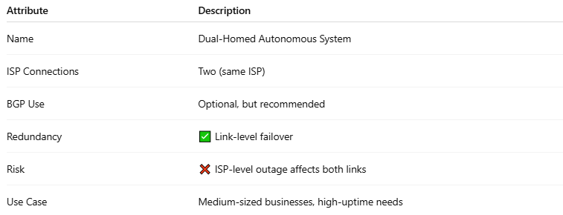
Attribute | Description
Name | Dual-Homed Autonomous System
ISP Connections | Two (same ISP)
BGP Use | Optional, but recommended
Redundancy | ✅ Link-level failover
Risk | ❌ ISP-level outage affects both links
Use Case | Medium-sized businesses, high-uptime needs

